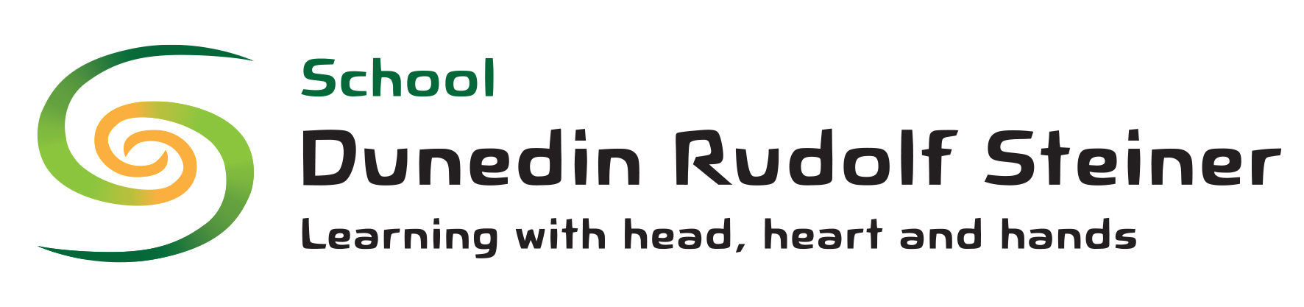
Policy on the teaching of te reo Māori (Māori language) and tikanga Māori (Māori culture)

This policy is written specifically to show the community how the school will respond if a parent seeks further instruction for their child in te Reo or tikanga Māori.

The curriculum recognises the unique position of Māori as tangata whenua in Aotearoa/ New Zealand, who in 1835 declared their sovereignty through He Whakaputanga Declaration of Independence. Tangata whenua are also partners to Te Tiriti o Waitangi 1840. Te reo Māori is the first language of tangata whenua and as such is an official language and a taonga or treasure and its value is upheld by te Tiriti o Waitangi. Students at our school will have the opportunity to learn some re reo Māori and to experience tikanga Māori.

All Māori content should enable connections between the children and the locally relevant stories, creation narratives, songs and places of significance, and an understanding of cultural values and dialect so as to build and enhance connection to place and connection to the mana whenua of this area.
Steiner education worldwide recognises the importance of children learning their own and other people’s cultures and language. This is embedded in the school curriculum and in the Steiner Curriculum on Te Reo Māori :. He Reo Puāwai

When a child is enrolled at the school, the school will outline its approach to the teaching of te reo and tikanga Māori in the special character interview with parents. Should a parent seek further instruction for their child in te reo or tikanga Māori, then the Principal will ensure that the parent is fully informed of the curriculum available. The Principal will then review whether there are alternative avenues to follow.

The Board is accountable for the school following and resourcing this policy and the Principal is responsible for ensuring this policy is followed. Teaching staff are also responsible to the Principal for following the policy to an expected standard and are consulted with on any changes. The school parent community is informed of this policy when their child is enrolled via the Parent Handbook, and prior to any changes.

Signed:

Dated: / / Review Date: / /

Kāi Tahu is the nationally recognised iwi that has mana whenua (traditional authority over the land) across the Otago district, coastal and central, as well as most of the South Island. This mana is held at a rūnaka level by Kāti Huirapa rūnaka ki Puketeraki at Karitane, and Te Rūnanga o Otakou, at Otakou. Kāi Tahu has a different dialect, including the replacement of of NG, with a K. The school has resources to teach oral and written Te Reo using the generalised dialect free Te Reo. When we speak of iwi, people, places and events that are connected to the local iwi, and in the karakia and waiata we learn from this area, we use the local dialect.

